**Tuning Cloudera Search HDFS/HBase Batch/NRT**

**Author: Michelle Zhang**

**Company: Cloudera**

**Date: 11/20/2014**

# Environment

Cluster: 3 nodes

DataNode, Regionserver, HMaster: 3 nodes

Memory: 32GB

CPU: 8*core Intel(R) Xeon(R) CPU E5-2670 v2 @ 2.50GHz

# Tuning MapReduce for Batch Indexer

## Tuning total memory

The total memory number can be calculated by:

Memory Total = yarn.nodemanager.resource.memory-mb * num of NodeManager

Enlarge yarn.nodemanager.resource.memory-mb value for NodeManager Default Group / Resource Management to increase total memory.

## Tuning total cpu

The total vcore number can be calculated by:

VCores Total = yarn.nodemanager.resource.cpu-vcores * num of NodeManger

Enlarge yarn.nodemanager.resource.cpu-vcores value for NodeManager Default Group / Resource Management to increase the total cpu cores.

## Tuning batch running Mapper number by memory

Batch running Mapper number can be calculated by memory and cpu resources.

Reduce client gateway mapreduce.map.memory.mb for Gateway Default Group / Resource Management, so that it can launch more reducer number:

mapreduce.map.memory.mb

## Tuning batch running Reduce number by memory

Batch running Reducer number can be calculated by memory and cpu resources.

Reduce client gateway mapreduce.reduce.memory.mb for Gateway Default Group / Resource Management, so that it can launch more reducer number:

mapreduce.reduce.memory.mb

## Tuning batch running Mapper JVM by memory

Batch running Mapper number can be calculated by memory and cpu resources.

Set client gateway mapreduce.map.java.opts.max.heap for Gateway Default Group / Resource Management, so that it can launch more reducer number:

mapreduce.map.memory.mb * 2/3

## Tuning batch running Reduce JVM by memory

Batch running Reducer number can be calculated by memory and cpu resources.

Set client gateway mapreduce.reduce.java.opts.max.heapfor Gateway Default Group / Resource Management, so that it can launch more reducer number:

mapreduce.reduce.memory.mb ＊ 2/3

# Tuning Solr for Batch Indexber

## Increase Java heap size for solr server group

Increase Java Heap Size of Solr Server in Bytes, for example 10GiB in Solr Server Group in CM Solr UI, and restart solr.

## Increase Java Direct Memory Size for solr server group

Increase Java Direct Memory Size of Solr Server in Bytes, for example 10GiB in Solr Server Group in CM Solr UI, and restart solr.

# Tuning Lily HBase Indexer for Batch HBase Indexer

## Enlarge --Reducers number

Enlarge “--reducers” value when specifying it in command line.

## Reduce auto commit in solrconfig.xml

     <autoCommit>

       <maxTime>${solr.autoCommit.maxTime:100}</maxTime>

       <openSearcher>false</openSearcher>

     </autoCommit>

The default number is 60000.

## Enlarge mapred JVM

Enlarge -D 'mapred.child.java.opts=-Xmx1024m’ value when specifying it in command line.

## Enable the concurrent low pause collector

Enable the concurrent low pause collector by adding following line in Java Configuration Options for Solr Server in Solr Server Group in CM Solr UI, and restart solr.

-XX:+UseConcMarkSweepGC -XX:-UseGCOverheadLimit

# Tuning Cloudera Search HDFS Batch

## Data Set Environment

Use TPCH to generate 2GB customer.tbl table. Using CSV format.

Data size: 2GB

Record: 15000000(15 million)

Record fields’ number: 9

Indexer Module: search-mr(MapReduceIndexerTool)

Search Module: Solr

## HDFS Batch Indexer

|  |  |
| --- | --- |
| **Job Name** | **Before Tuning** |
| org.apache.solr.hadoop.MapReduceIndexerTool/MorphlineMapper | 6min 34s |

## HDFS Batch Search

Search time response within 2s.

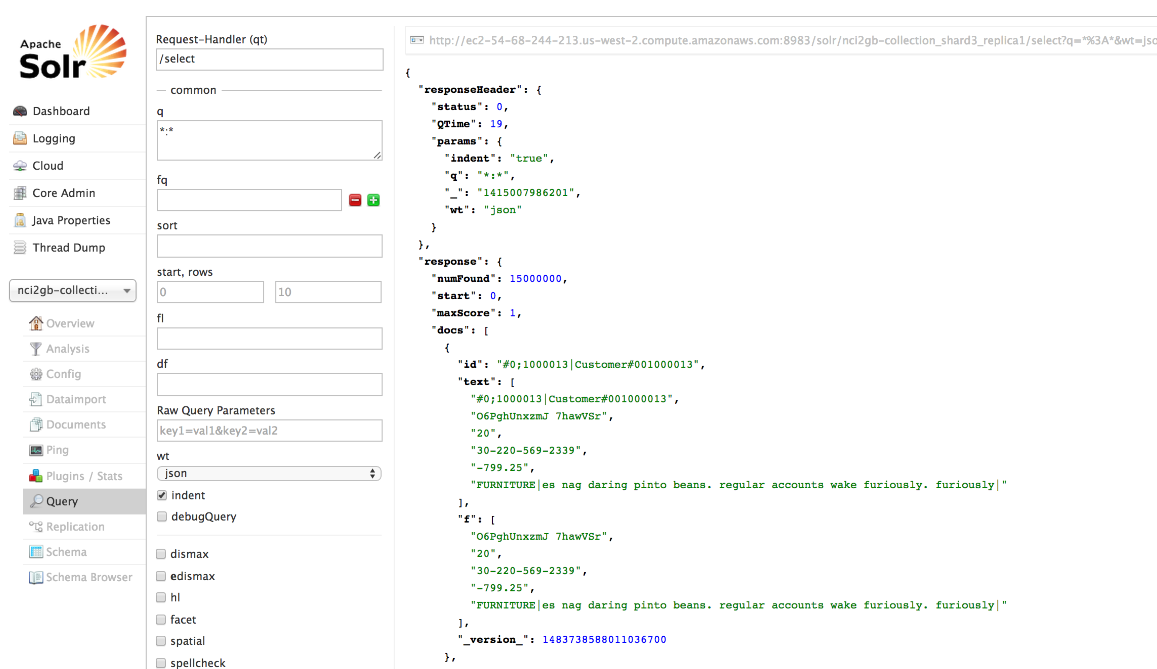

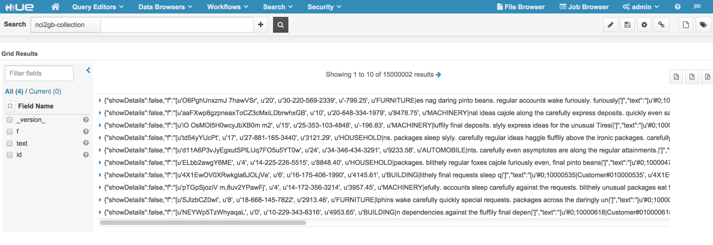

# Tuning Cloudera Search HDFS NRT

## Data Set Environment

Use TPCH to generate 2GB customer.tbl table. Using CSV format.

Data size: 2GB

Record: 15000000(15 million)

Record fields’ number: 9

Indexer Module: Flume

Search Module: Solr

## HDFS NRT Indexer

Indexer time responses immediately, and increase continually.

## HDFS NRT Search

Search time responses within 1s immediately, and increase continually.

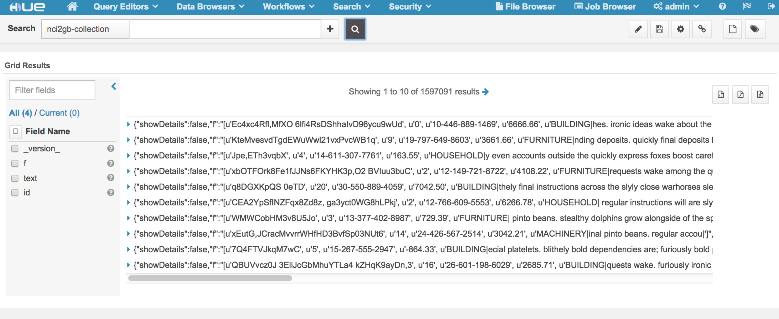

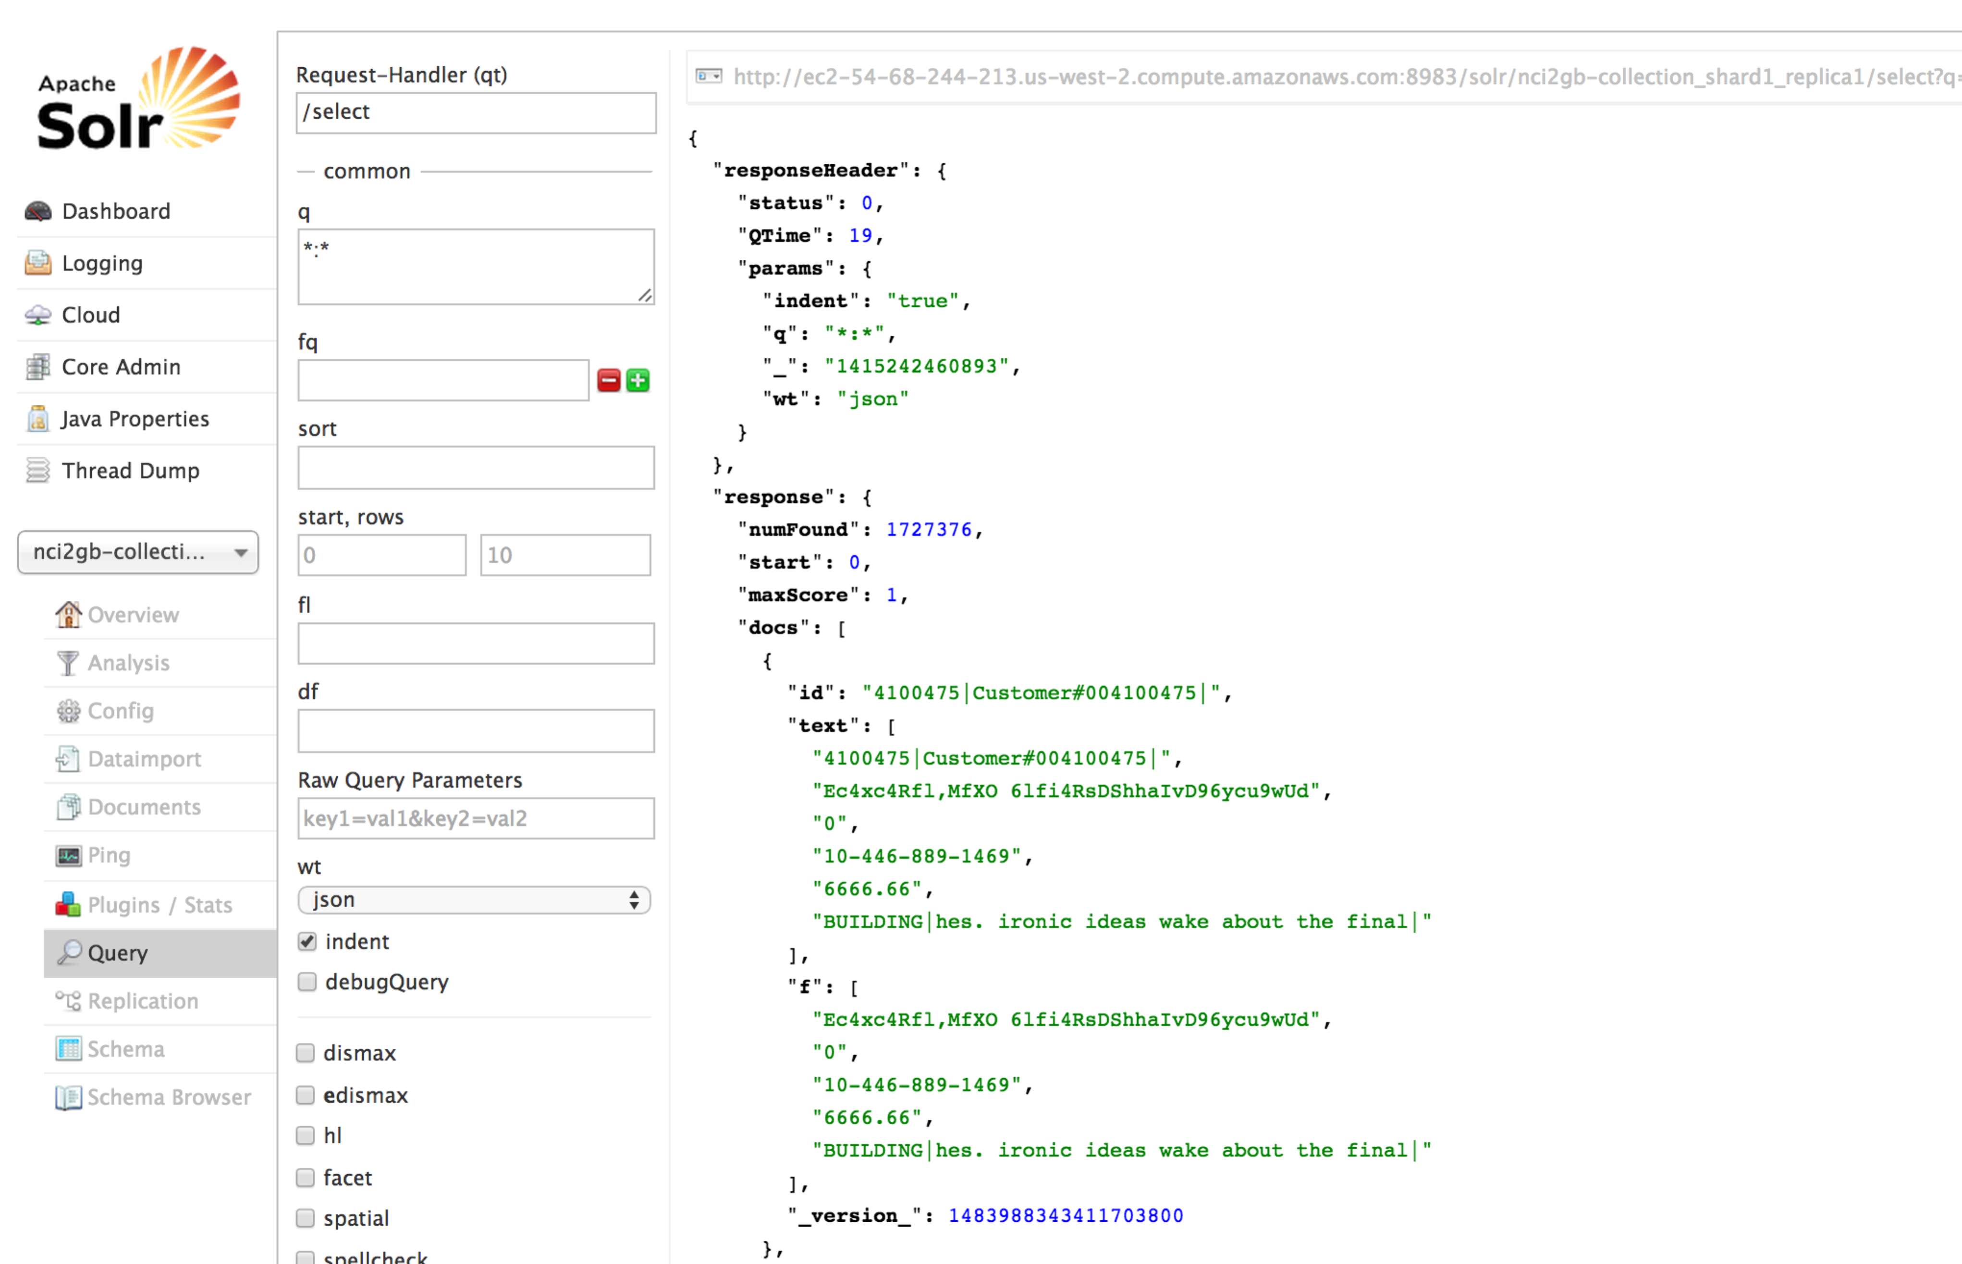

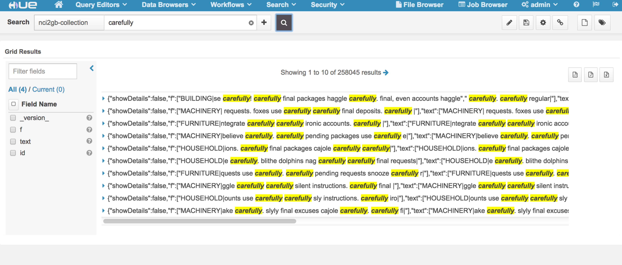

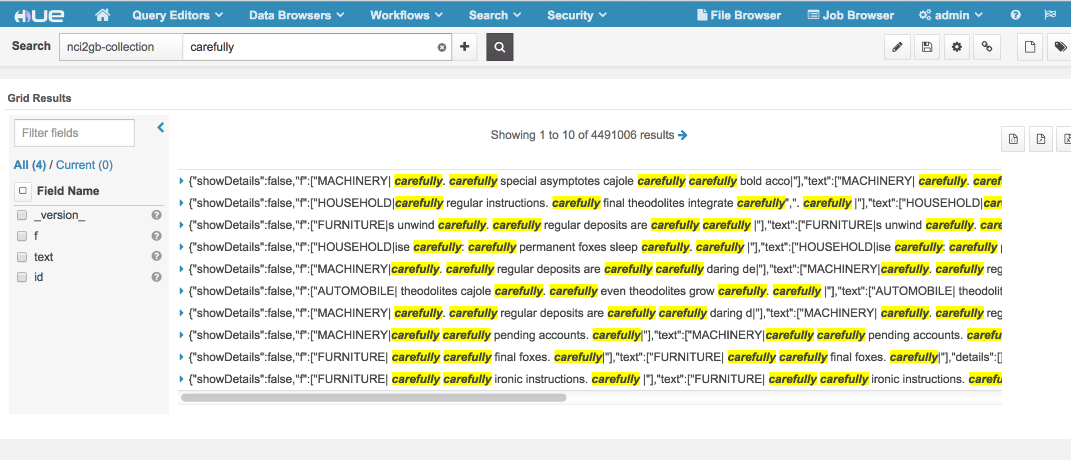

Finally, all are indexed and searchable.

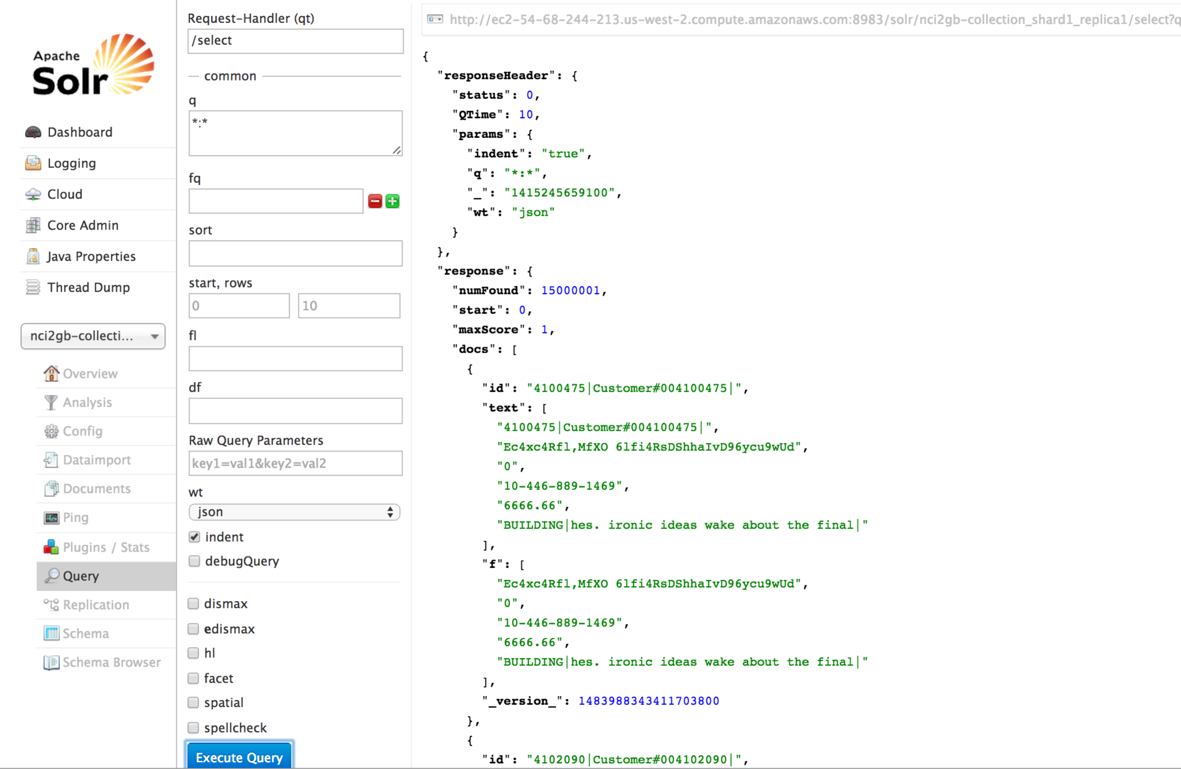

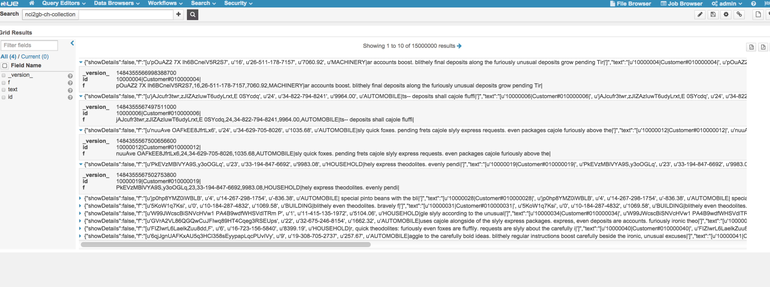

# Tuning Cloudera Search HBase Batch

## Data Set Environment

Use TPCH to generate 20GB customer.tbl table.

Data size: 20GB

Record: 120000000(120 million)

Record fields’ number: 9

Indexer Module: Lily HBase, hbase-indexer-mr(HBaseMapReduceIndexerTool)

Search Module: Solr

## HBase Batch Indexer

|  |  |  |  |
| --- | --- | --- | --- |
| **Job Name** | **Reduce number** | **Before Tuning** | **After Tuning** |
| HBaseMapReduceIndexerTool/HBaseIndexerMapper | 6 | 2hr 13min 1s |  |
| org.apache.solr.hadoop.ForkedMapReduceIndexerTool/ForkedTreeMergeMapper | 6 | 35min 31s |  |
| Go-live phase copy indexes to HDFS output shard directories | 6 | 27min 23s |  |
| HBaseMapReduceIndexerTool/HBaseIndexerMapper | 140 |  | 1hr 23min 21s |
| org.apache.solr.hadoop.ForkedMapReduceIndexerTool/ForkedTreeMergeMapper | 140 |  | 32min 11s |
| HBaseMapReduceIndexerTool/HBaseIndexerMapper | 240 |  | 50min 55s |
| org.apache.solr.hadoop.ForkedMapReduceIndexerTool/ForkedTreeMergeMapper | 240 |  | 33min 11s |
| Go-live phase copy indexes to HDFS output shard directories | 240 |  | 27min 6s |

|  |  |
| --- | --- |
| Original Data Size | Solr Indexer Size |
| 19,807,331,495B | 43,160,202,966B |

**Data Size about Index:**

## HBase Batch Search

Search time response within 2s.

2GB:



20GB:

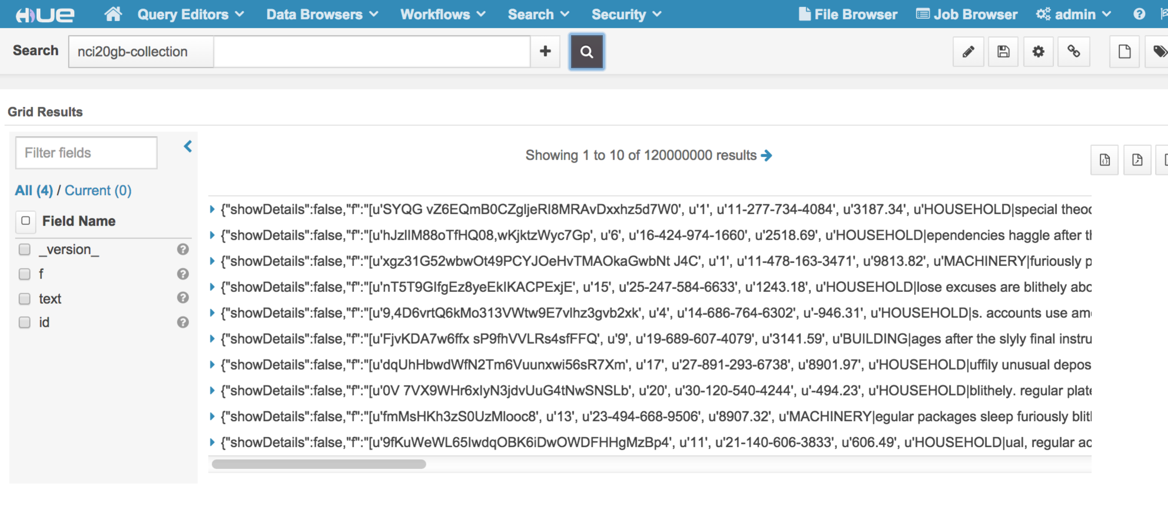

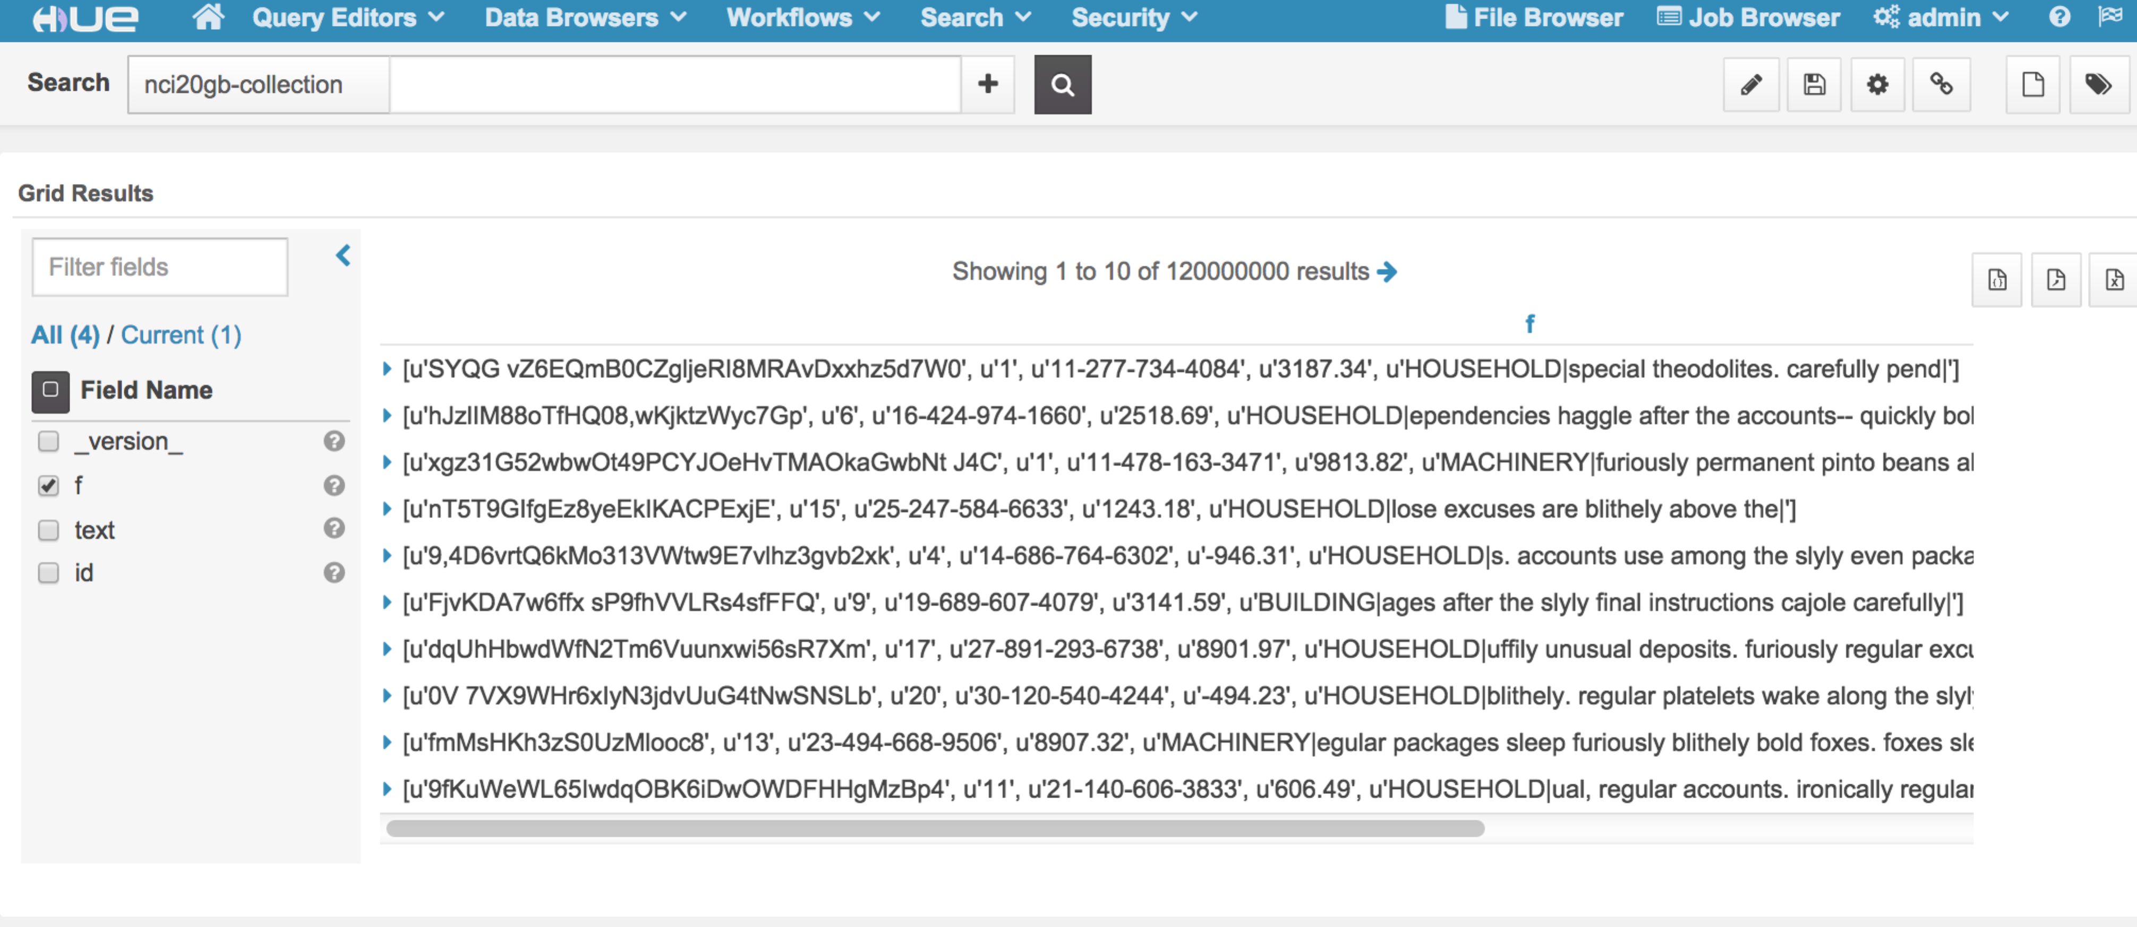

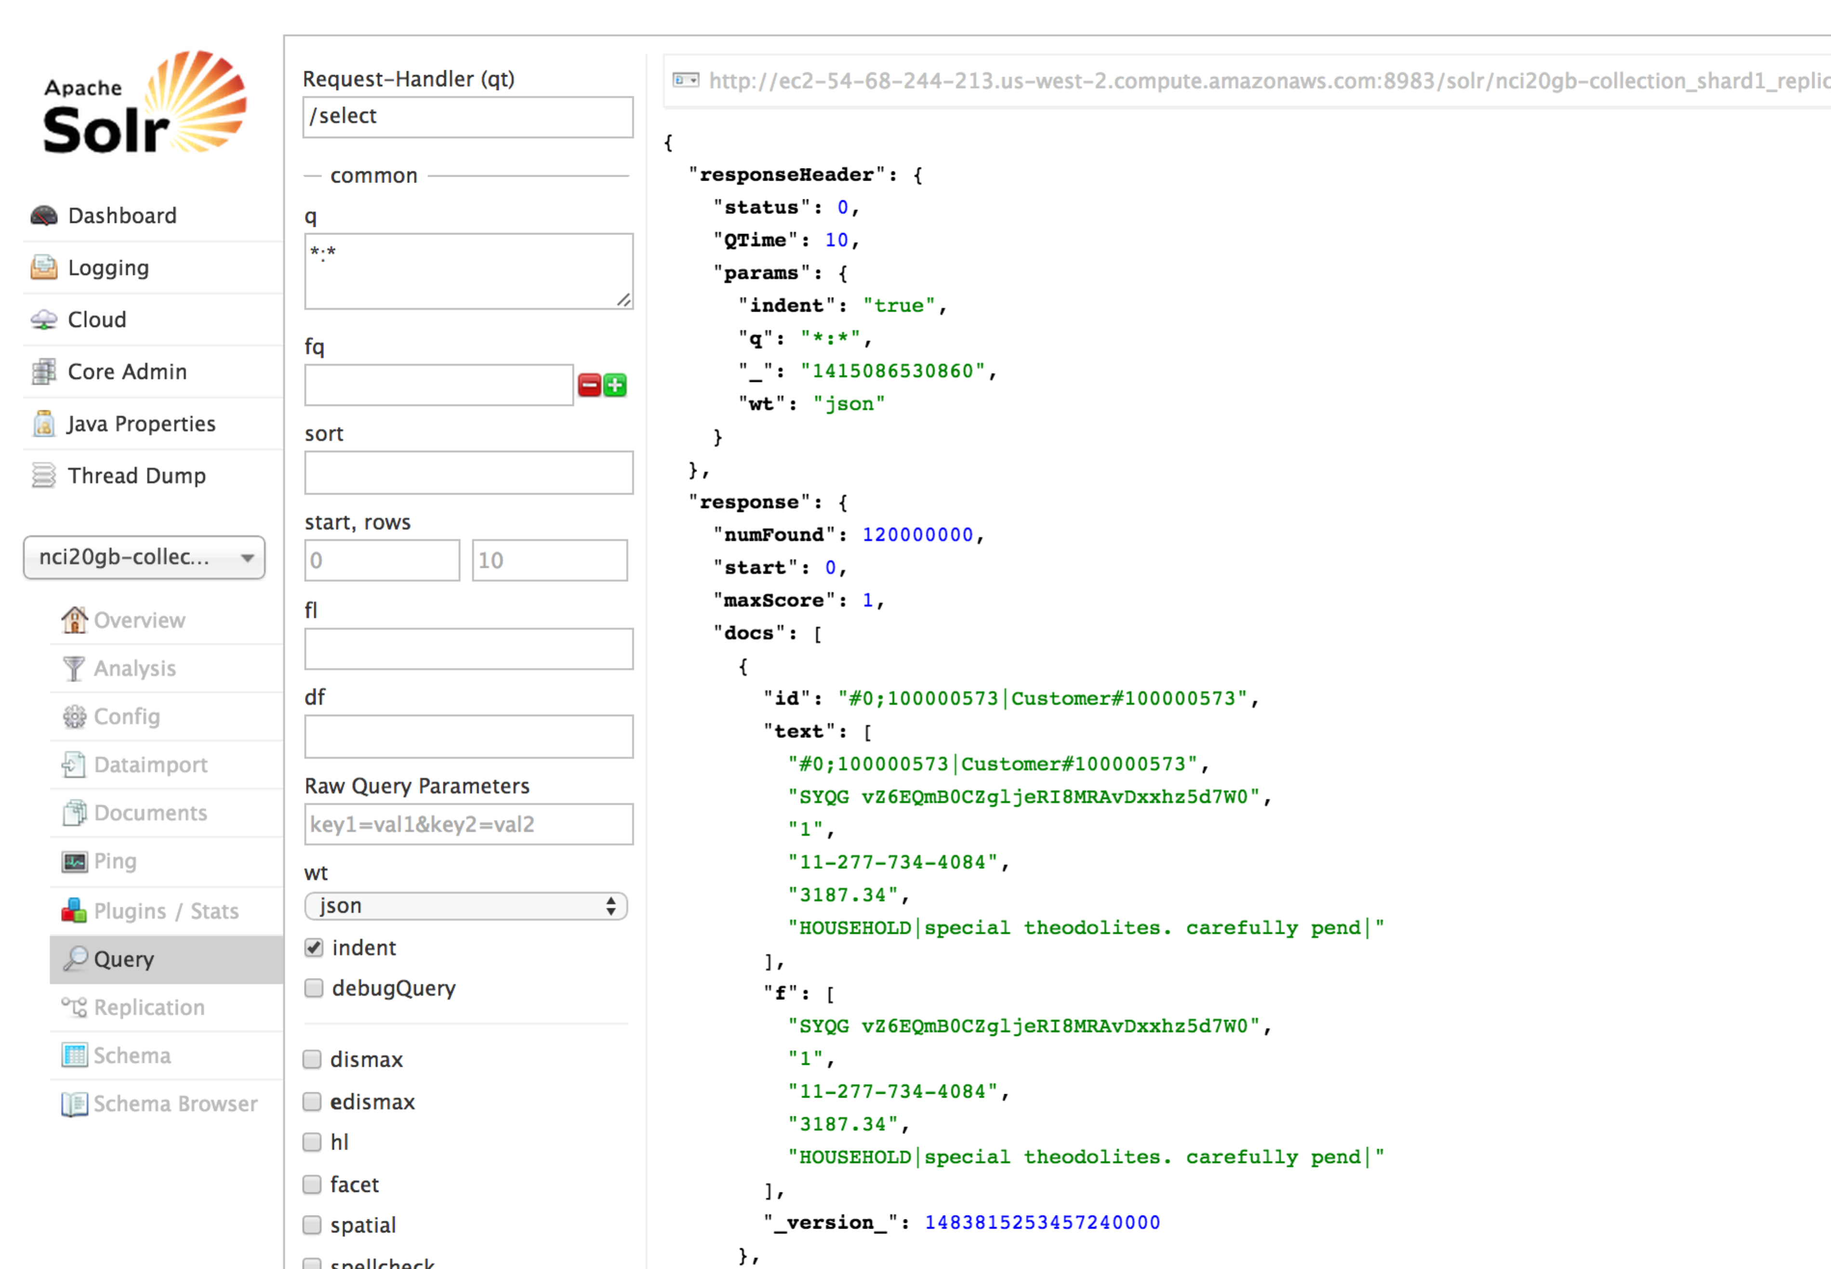

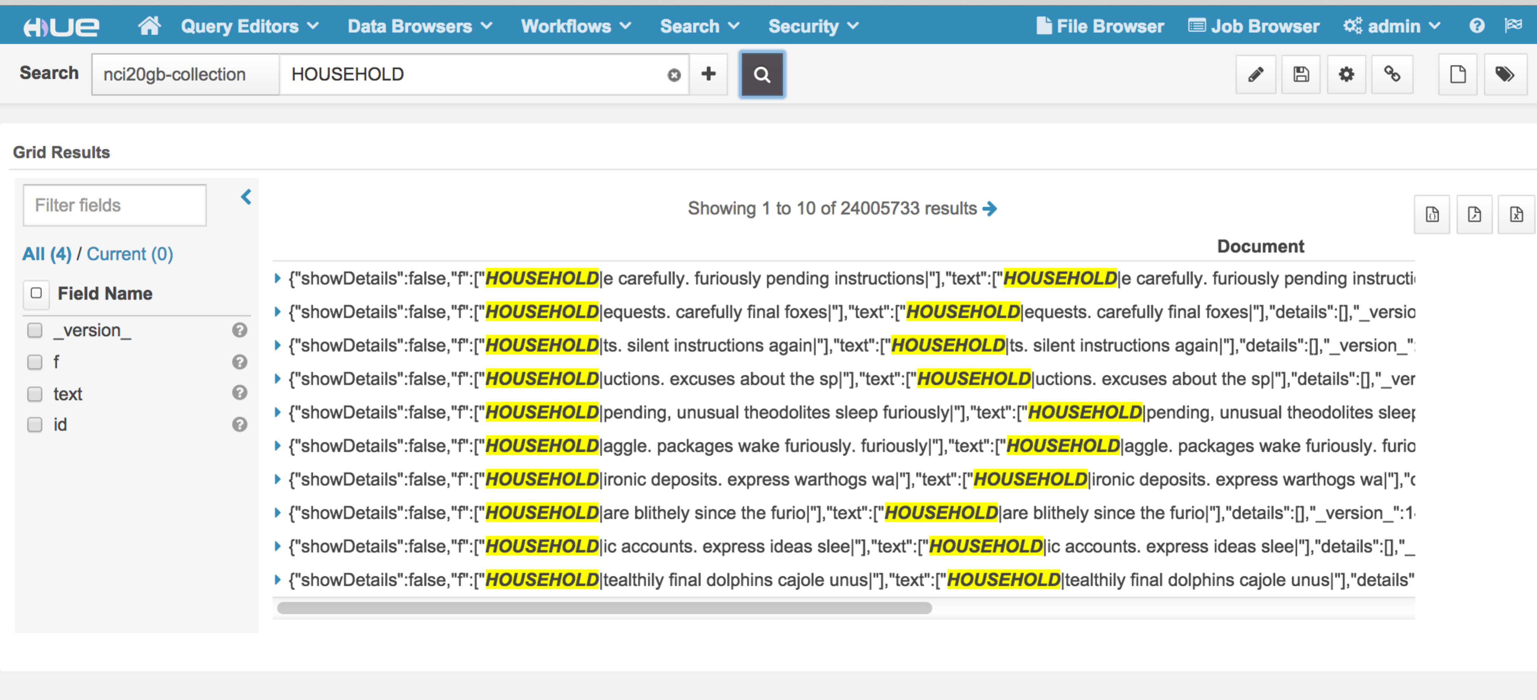

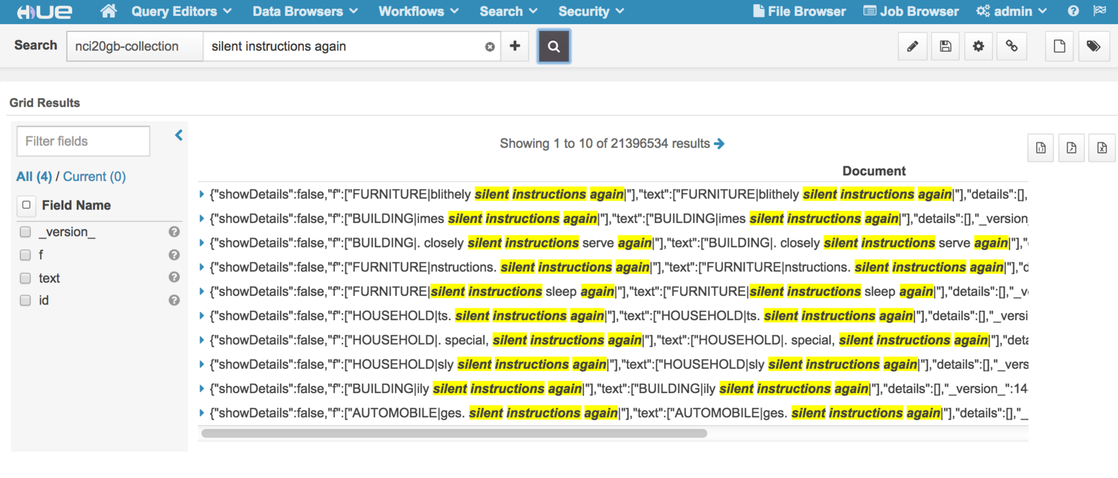

# Tuning Cloudera Search HBase NRT

## Data Set Environment

Use TPCH to generate 2GB customer.tbl table.

Data size: 2GB

Record: 15000000(15 million)

Record fields’ number: 9

Indexer Module: Lily HBase, hbase-indexer

Search Module: Solr

Near Real Time (NRT) data load: MapReduce load

## HBase NRT Indexer

|  |  |  |
| --- | --- | --- |
| **NRT Load Simulation** | **Load Time(Not Using HBase NRT Indexer)** | **Load Time (Using NRT Indexer)** |
| MapReduce Load | 6min 37s | 8min 8s |

Indexer time responses immediately, and increase continually

## HBase NRT Search

Search time response within 1s immediately, and increase continually

2GB:



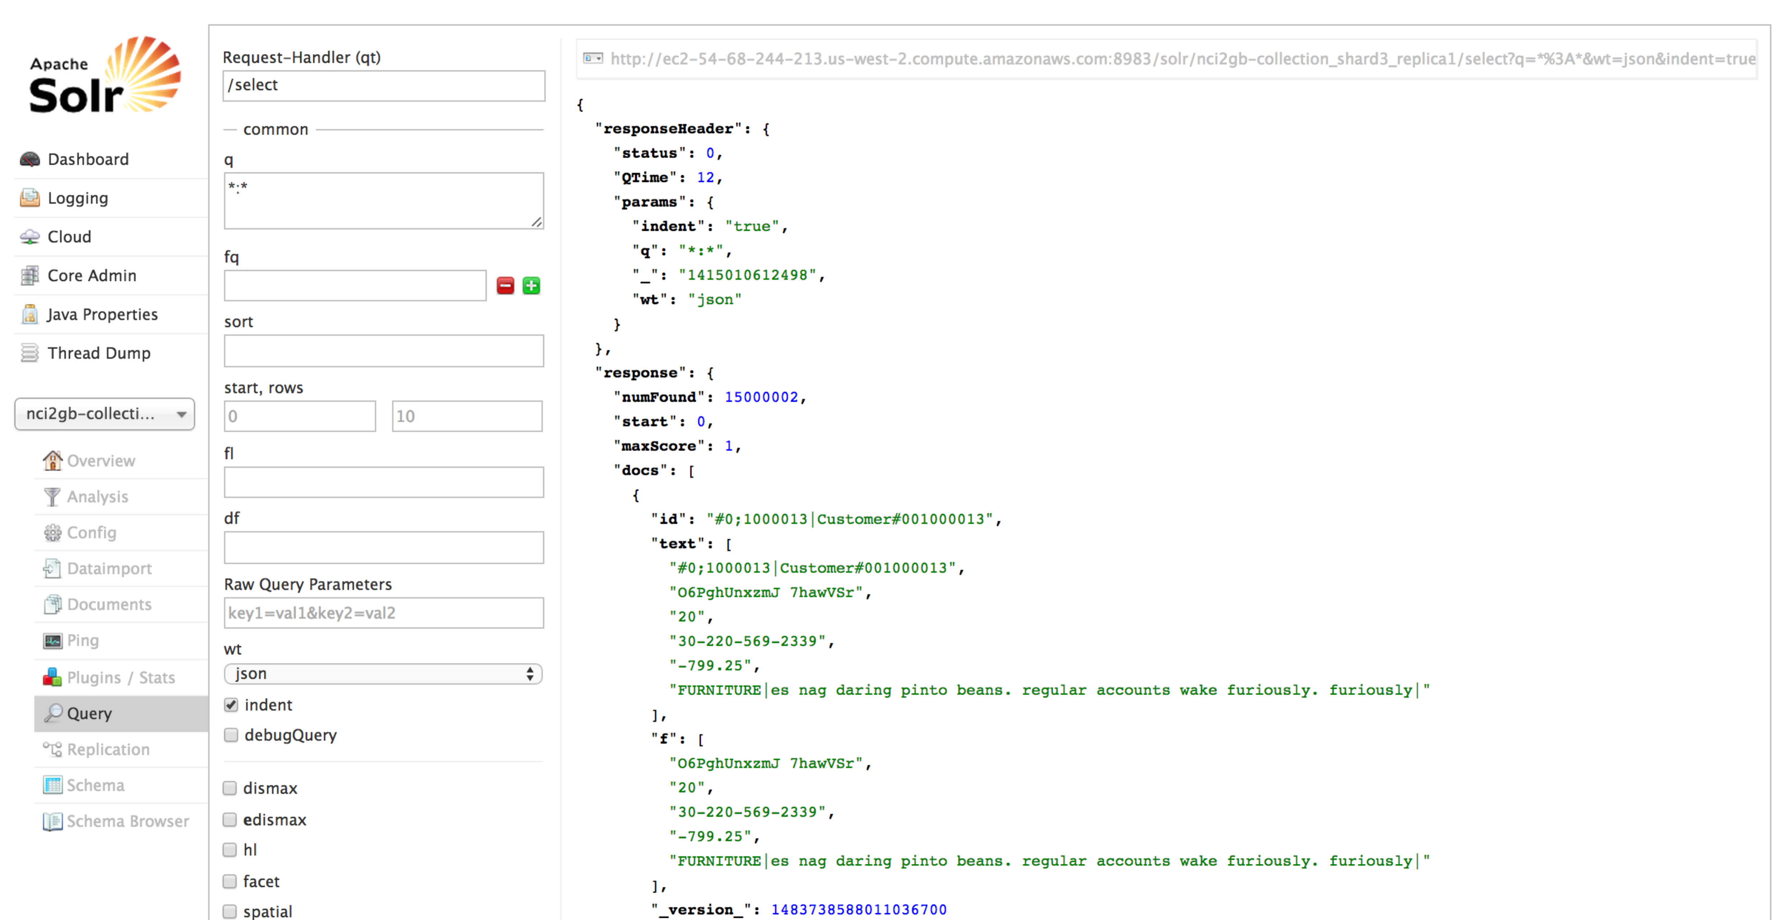

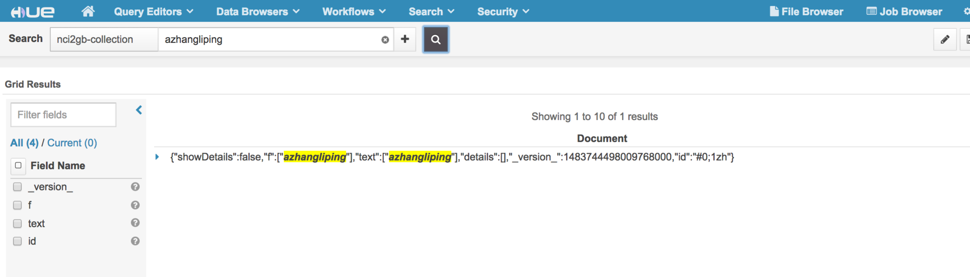

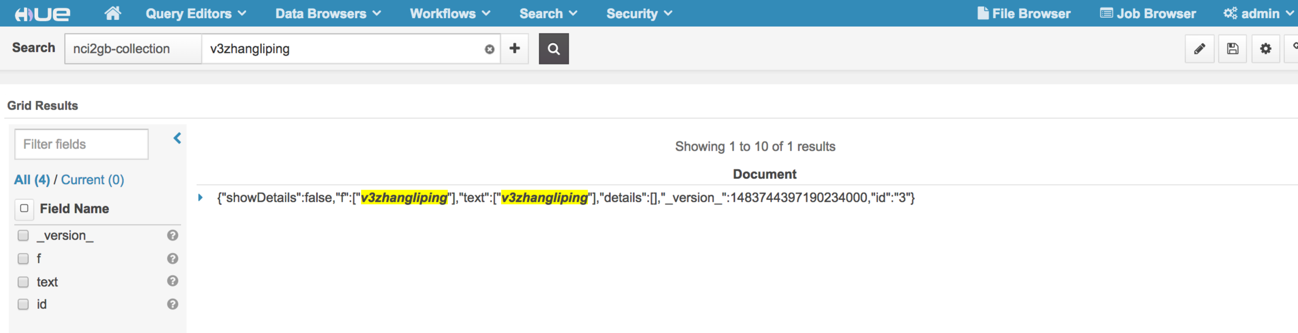

# Tuning Cloudera Search Chinese Segmentation with HBase Batch

## Data Set Environment

Use TPCH to generate 2GB customer.tbl table.

Data size: 2GB

Record: 15000000(15 million)

Record fields’ number: 9

Indexer Module: Lily HBase, hbase-indexer-mr(HBaseMapReduceIndexerTool)

Search Module: Solr

Search Chinese Segmentation: lucene-analyzers-smartcn-4.4.0-cdh5.2.0.jar

## Chinese Segmentation with HBase Batch Indexer

|  |  |  |
| --- | --- | --- |
| **Job Name** | **Before Tuning** | **After Tuning** |
| HBaseMapReduceIndexerTool/HBaseIndexerMapper | Never finished | 44min 58s |
| org.apache.solr.hadoop.ForkedMapReduceIndexerTool/ForkedTreeMergeMapper | Never start | 1min 30s |

## Chinese Segmentation search with HBase Batch Indexer

Search time response within 1s.